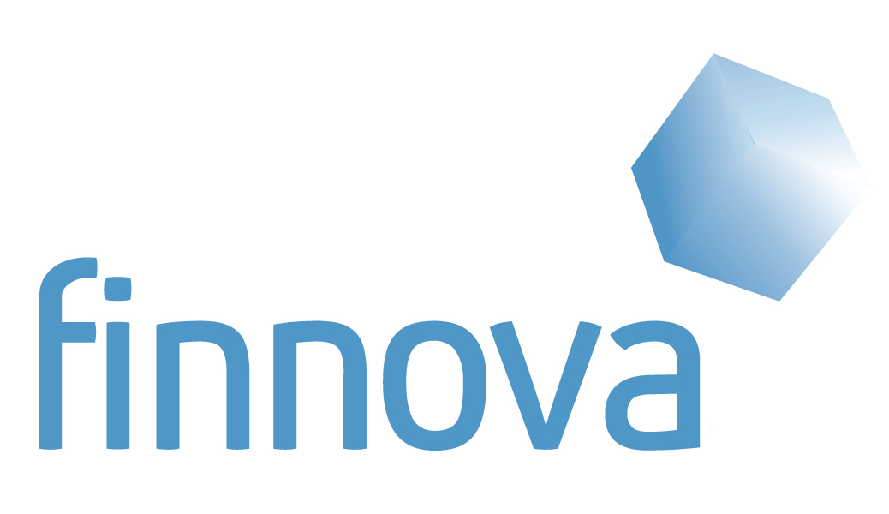




The European Commissioner for transport supports the innovation project Nobel Grid coordinated by the multinational technological company Etra

• The Commissioner visited the stand of Nobel Grid at the Metropolitan Solutions of Berlin, the main global event on Smart Cities.
• Nobel Grid main objective is to offer tools to improve the European Smart Grids.
• The project has 21 European partners and receives funds of nearly 14 million euros from the European Commission.

Berlin, 22nd May, 2015. - The European Commissioner for transport, Violeta Bulc, has demonstrated her support for the Nobel Grid project in the Metropolitan Solutions event of Berlin. There, she visited the stand were Antonio Marques, Director of Technology at Etra I+D and Juan Manuel Revuelta, Director at Finnova, have exposed the Nobel Grid project during the 20th, 21st and 22nd in what is considered the greater global event on intelligent and sustainable cities, the so called Smart Cities. The Commissioner has expressed her support to the project due to its contribution to the possibilities offered to citizens to make use of clean energies in a cheap way, due to the integration of all the sectors of the electric market and due to the tools offered to the European companies to be more competitive in the energy sector. Bulc appreciated the work of the Nobel Grid partners to achieve a more efficient, safe and cheaper electric system which will benefit all the stakeholders.

About Nobel Grid, Smart energy for people
Nobel Grid is a project led by the multinational company Etra with the aim of offering tools to achieve safer, stable, sustainable and cheaper electric networks. The project is funded by the Research and Innovation Programme of the European Commission, Horizon2020 with 13,8 million euros. Nobel Grid is currently the most relevant innovation project of the European Union. 21 partners from 11 European countries participate among which there are 5 pilot sites. The project that started in January will have a duration of four years.
Nobel Grid aims to be protagonist in this innovative market through the creation of the most competitive and reliable Smart Meter, the implantation of new services for all stakeholders and the creation of reliable solutions and tools which will be tested in real conditions in different scenarios.
www.nobelgrid.eu

About Metropolitan Solutions, the greater event on future cities
The Metropolitan Solutions offered a total of 27 conferences in which more than 4.000 experts worldwide have participated to promote the sustainable and intelligent cities of tomorrow. In a parallel exposition, 150 international companies have exposed their technologies in all imaginable aspects related to the cities of the future. Metropolitan Solutions is the bigger conference and commercial fair of the world on intelligent and green cities.
http://www.metropolitansolutions.de

About Etra, leading multinational technology company in mobility, energy and integrated services
ETRA is a leading Industrial Group which constitutes the Smart City Center of Excellence of ACS Corporation. This key position is based in ETRA’s intense research, development and innovation activities. ETRA’s mission is putting technology to work for serving society in the fields of mobility, energy efficiency, security and communications. The Company expertly and effectively combines the Smart City technology model with the provision of specific, tangible solutions which do improve citizen’s quality of life as well as the efficiency of city services managers (be them public or private) in the use of their limited human, material and environmental resources.
ETRA leads the 21 partners consortium developing NOBELGRID project.
www.etra.es

About Finnova, European foundation promoting innovation in Europe
Finnova Foundation, as a partner of Nobel Grid is in charge of international communication, advices all partners in legal issues, fights against legal and regulatory barriers for the implantation of Smart grids and is creating a training e-learning platform to share the acquired knowledge. The foundation is also proposing a new business model to ease new financial and business formulas which allow investment for its development.
www.finnova.be

There is graphic material available

For more information:

- Lola Alacreu
NOBELGRID Project Manager
e-mail: lalacreu.etraid@grupoetra.com
Tlf:+34-963.13.40.82
Web: www.etra.es

- Cristina Villalba
Communication Director of Finnova
E-mail: communication@finnova.be
Tel: +34-696.38.27.04
Web: www.finnova.be

Web: www.nobelgrid.eu

